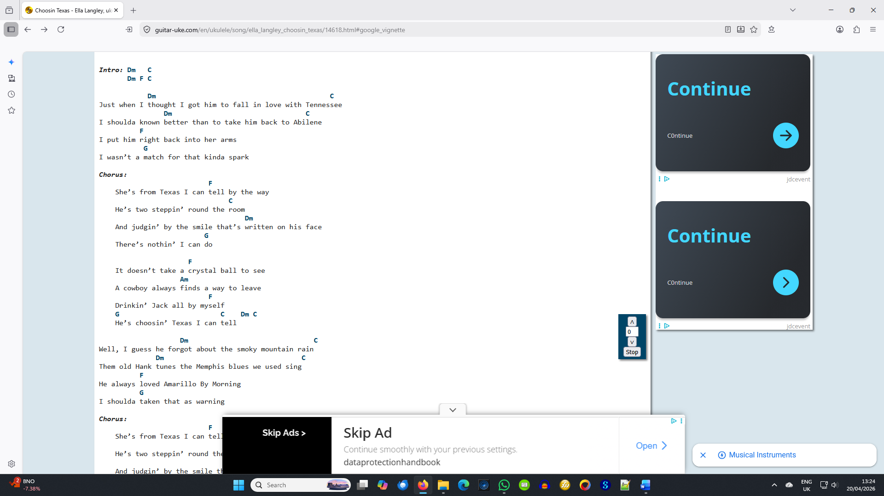
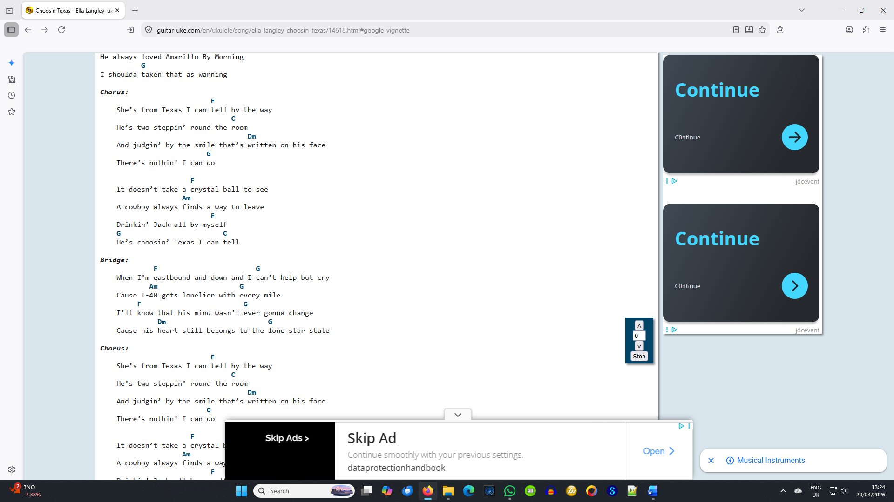
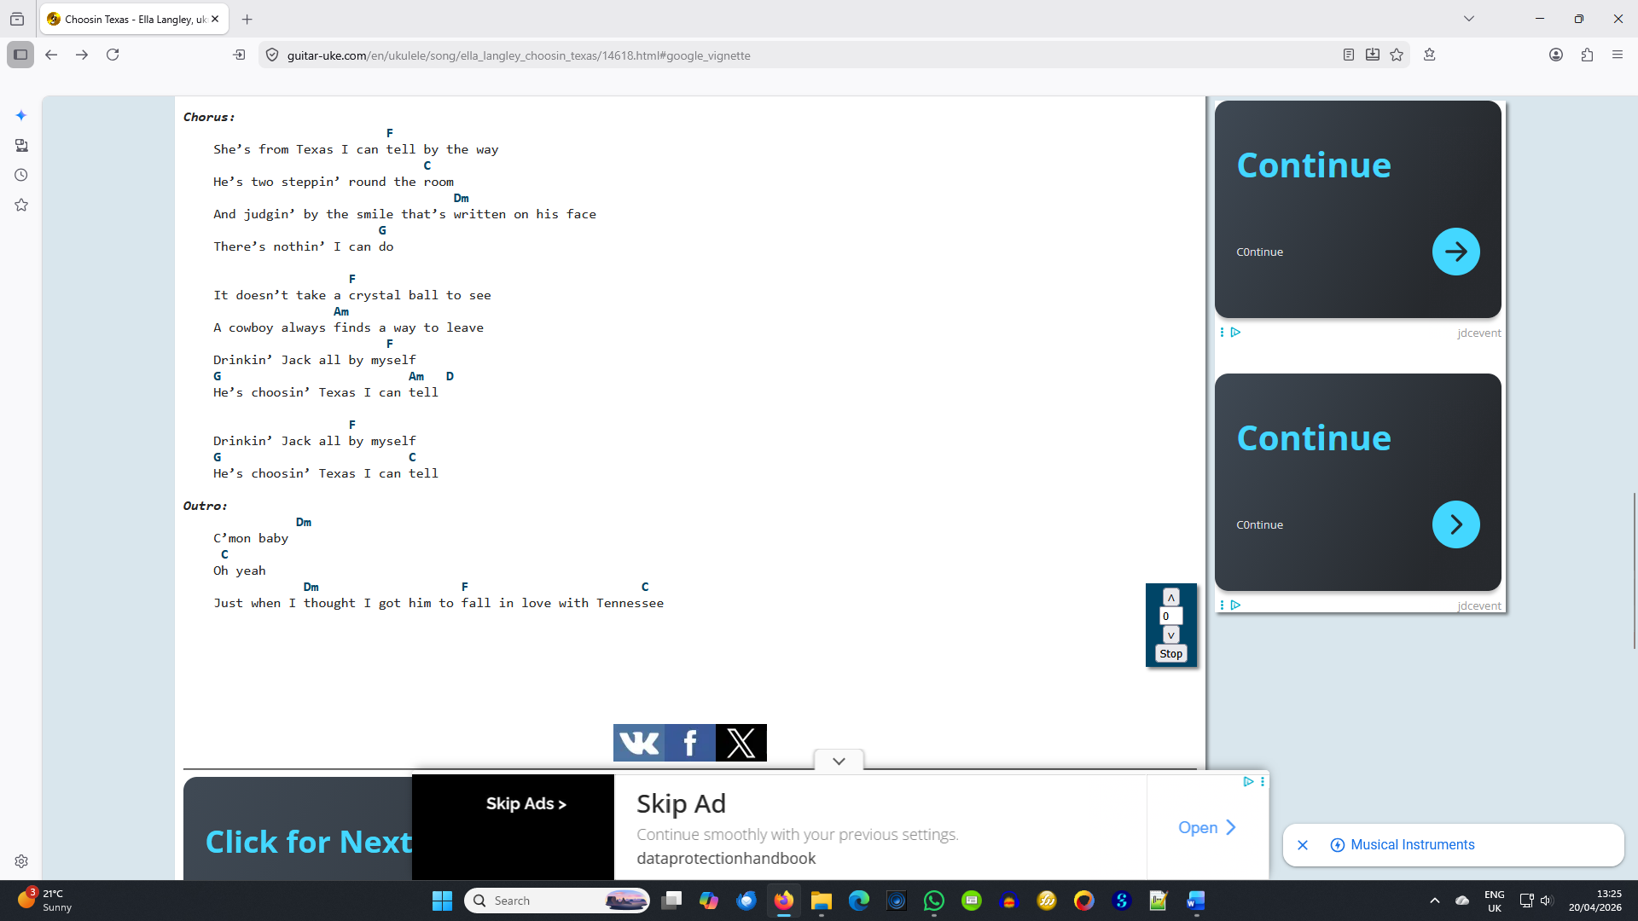
Intro: Dm C
Dm F C

Dm C
Just when I thought I got him to fall in love with Tennessee
Dm C
I shoulda known better than to take him back to Abilene
F
I put him right back into her arms
G
I wasnʼt a match for that kinda spark

Chorus:
F
Sheʼs from Texas I can tell by the way
C
Heʼs two steppinʼ round the room
Dm
And judginʼ by the smile thatʼs written on his face
G
Thereʼs nothinʼ I can do

F
It doesnʼt take a crystal ball to see
Am
A cowboy always finds a way to leave
F
Drinkinʼ Jack all by myself
G C Dm C
Heʼs choosinʼ Texas I can tell

Dm C
Well, I guess he forgot about the smoky mountain rain
Dm C
Them old Hank tunes the Memphis blues we used sing
F
He always loved Amarillo By Morning
G
I shoulda taken that as warning

Chorus:
F
Sheʼs from Texas I can tell by the way
C
Heʼs two steppinʼ round the room
Dm
And judginʼ by the smile thatʼs written on his face
G
Thereʼs nothinʼ I can do

F
It doesnʼt take a crystal ball to see
Am
A cowboy always finds a way to leave
F
Drinkinʼ Jack all by myself
G C
Heʼs choosinʼ Texas I can tell

Bridge:
F G
When Iʼm eastbound and down and I canʼt help but cry
Am G
Cause I-40 gets lonelier with every mile
F G
Iʼll know that his mind wasnʼt ever gonna change
Dm G
Cause his heart still belongs to the lone star state

Chorus:
F
Sheʼs from Texas I can tell by the way
C
Heʼs two steppinʼ round the room
Dm
And judginʼ by the smile thatʼs written on his face
G
Thereʼs nothinʼ I can do

F
It doesnʼt take a crystal ball to see
Am
A cowboy always finds a way to leave
F
Drinkinʼ Jack all by myself
G Am D
Heʼs choosinʼ Texas I can tell

F
Drinkinʼ Jack all by myself
G C
Heʼs choosinʼ Texas I can tell

Outro:
Dm
Cʼmon baby
C
Oh yeah
Dm F C
Just when I thought I got him to fall in love with Tennessee

